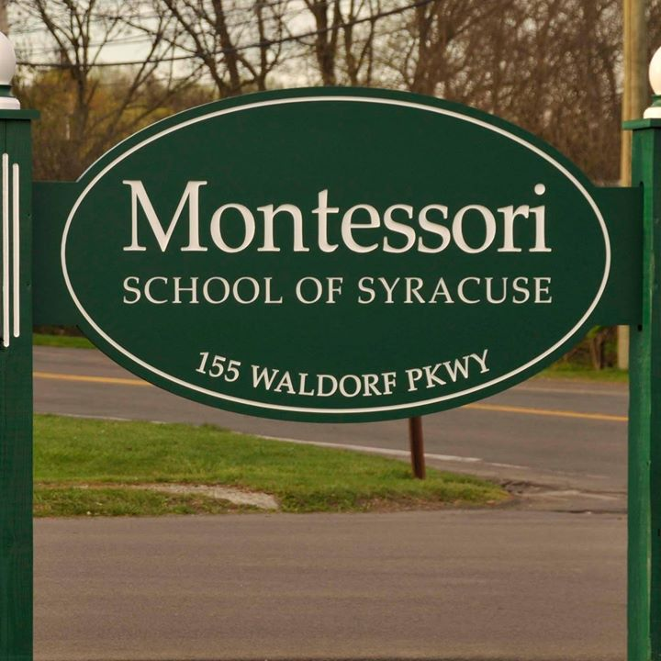

MINIMUM CAPACITY :-
The Minumum intake capacity
of students is between 400-620
children

LIBRARY :-
The Libarary is Available.

CANTEEN:-
The Canteen Facility is Available.

BOARDING :-
No availablility of boarding.

SPORTS :-
There are different categories
sports available.
Girls Volleyball
Boys Volleyball
Football

MONTESSORI SCHOOL OF SYRACUSE
SYRACUSE - SCHOOL

School Detail :-
The Montessori School of Syracuse sits on an eight-acre campus near the intersection of Tecumseh and Nottingham roads in DeWitt. Our students also enjoy the use of the Montessori Land Laboratory, a 50-acre wooded property with a pond and buildings in Pompey.
In addition to the traditional school subjects such as mathematics, science, history and language arts (reading, writing and grammar), we offer a broad range of subjects designed to enrich our students’ personal and academic development. These subjects include French, music history, geography, geometry, and Great Books.

